BASIC PROGRAMMING
CHAPTER 1 - INDIVIDUAL PRACTICAL ASSIGNMENT
STUDENT REPORT TEMPLATE
Assignment 3 Company Fixed Asset Recording Form

Student Information
Student Name : Garini SahasraKirana
Student ID (NIM) : 4.41.25.9.06
Class / Semester :KA-2IUP
Study Program : Computerize accounting
Submission Date :

Course Lecturer
Ahmad Wafa Mansur, S.ST., M.IM.
Computerized Accounting Study Program
Department of Accounting, Politeknik Negeri Semarang

Report Instructions
Complete only the sections below using your own Assignment work. Keep explanations concise, use readable evidence, and export the completed report to PDF.

1. Assignment Information
Assignment
Project Folder | week_3/Company Fixed Asset Recording Form/
Main File
Repository Link

2. HTML Source Code
Paste the final HTML code from Assignment. Use consistent indentation. Additional pages may be used if required.
<!DOCTYPE html>
<html lang="en">
<head>
<meta charset="UTF-8">
<meta name="viewport" content="width=device-width, initial-scale=1.0">
<title>Company Fixed Asset Recording Form </title>
</head>
<body>
<h1>Company Fixed Asset Recording Form</h1>
<form method="post" action="#" enctype="multipart/form-data">

<h1>Asset Identification</h1>

<fieldset>
<legend>Asset Information</legend>
<p>
<label for="Assetname">Asset Name:</label>
<input type="text" placeholder="Automated Production Machine" id="Assetname" name="Assetname" required>
</p>
<p>
<label for="Assetcode">Asset Code:</label>
<input type="text" placeholder="XH-106157" id="Assetcode" name="Assetcode" required>
</p>
<p>
<label for="AssetSerialNumber">Asset Serial Number:</label>
<input type="text" placeholder="Enter asset serial number" id="AssetSerialNumber" name="AssetSerialNumber">
</p>
<p>
<label for="AssetCategory">Asset Category:</label><br>
<select id="AssetCategory" name="AssetCategory" required>
<option value="Vehicle">Vehicle</option>
<option value="Machinery">Machinery</option>
<option value="Building">Building</option>
<option value="Office Equipment">Office Equipment</option>
<option value="Furniture">Furniture</option>
<option value="Land">Land</option>
<option value="Software">Software</option>
</select>
</p>
</fieldset>

<h1>Acquisition Details</h1>

<fieldset>
<legend>Acquisition Information</legend>
<p>
<label for="ad">Acquisition Date:</label>
<input type="date" id="ad" name="ad" required>
</p>
<p>
<label for="AcquisitionValue">Acquisition Value / Purchase Price:</label>
<input type="number" min="0" step="1000" placeholder="50000000" id="AcquisitionValue" name="AcquisitionValue" required>
</p>
<p>
Acquisition Method:<br>

<input type="radio" id="CashPurchase" name="AcquisitionMethod" value="CashPurchase" required>
<label for="CashPurchase">Cash Purchase</label><br>

<input type="radio" id="CreditPurchase" name="AcquisitionMethod" value="CreditPurchase">
<label for="CreditPurchase">Credit Purchase</label><br>

<input type="radio" id="FinanceLease" name="AcquisitionMethod" value="FinanceLease">
<label for="FinanceLease">Finance Lease</label><br>

<input type="radio" id="Donation" name="AcquisitionMethod" value="Donation">
<label for="Donation">Donation</label><br>
</p>
<p>
<label for="Vendor">Vendor/Supplier:</label>
<input type="text" id="Vendor" name="Vendor" required>
</p>
<p>
<label for="UploadAcquisition">Upload Acquisition Documents:</label>
<input type="file" accept=".pdf,.jpg,.png" id="UploadAcquisition" name="UploadAcquisition" multiple>
</p>
</fieldset>

<h1>Depreciation Fixed Asset</h1>

<fieldset>
<legend>Depreciation Information</legend>
<p>
<label for="UsefulLife">Useful Life (in years):</label>
<input type="number" id="UsefulLife" name="UsefulLife" min="1" max="50" placeholder="5">
</p>

<p>
<label for="SalvageValue">Salvage Value:</label>
<input type="number" id="SalvageValue" name="SalvageValue" min="0" step="1000" placeholder="5000000">
</p>
<p>
<label for="DepreciationMethod">Depreciation method:</label>
<select id="DepreciationMethod" name="DepreciationMethod" required>
<option value="Straight Line">Straight Line</option>
<option value="Declining Balance">Declining Balance</option>
</select>
</p>
</fieldset>

<h1>Responsible Person And Location</h1>

<fieldset>
<legend>Responsible Person Information</legend>
<p>
<label for="ResponsiblePerson">Responsible Person's name:</label>
<input type="text" id="ResponsiblePerson" name="ResponsiblePerson" required>
</p>
<p>
<label for="UserDepartment">User Department:</label>
<input type="text" id="UserDepartment" name="UserDepartment" placeholder="Production / Accounting" required>
</p>
<p>
<label for="AssetPhysicalLocation">Asset Physical Location:</label>
<input type="text" placeholder="3rd Floor Main Building" id="AssetPhysicalLocation" name="AssetPhysicalLocation" required>
</p>
<p>
<label for="ResponsibleEmail">Responsible Person Email:</label>
<input type="email" id="ResponsibleEmail" name="ResponsibleEmail" required>
</p>
</fieldset>
<p>
<input type="submit" value="Submit">
<input type="reset" value="Reset">
</p>
</form>

</body>
</html>

3. Browser Result
Insert one or two readable screenshots showing the completed page and its required elements.
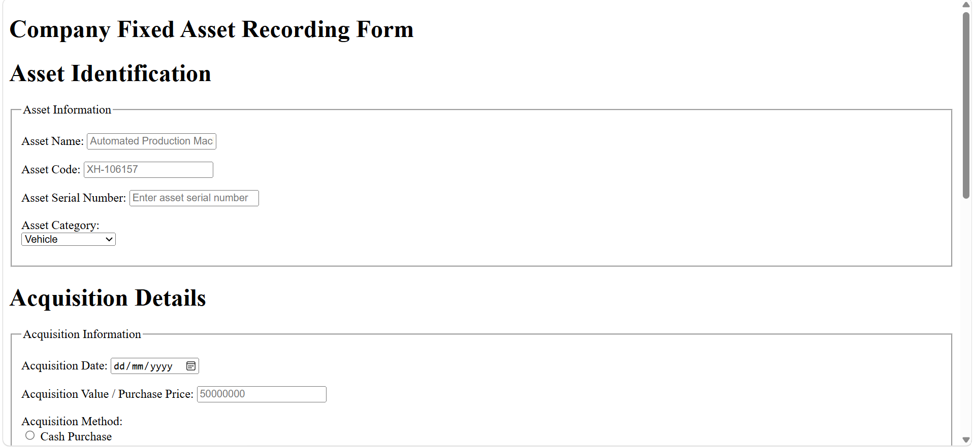
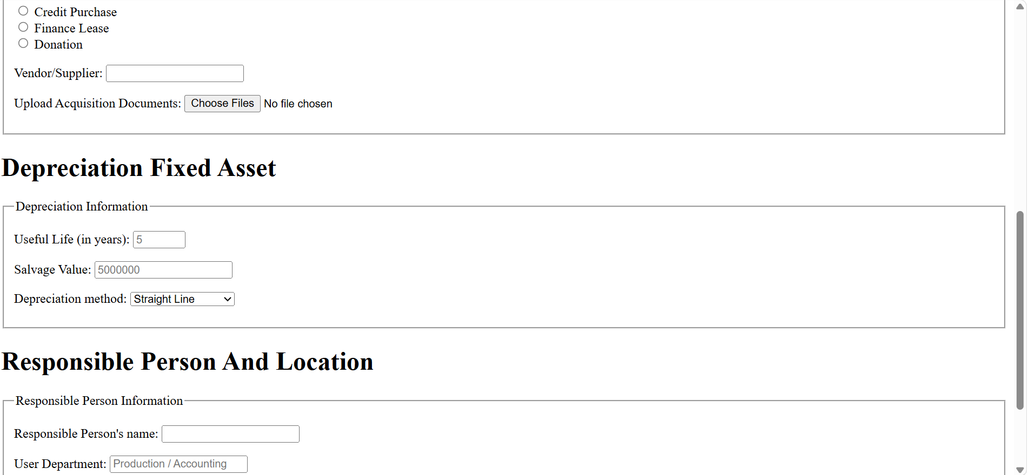
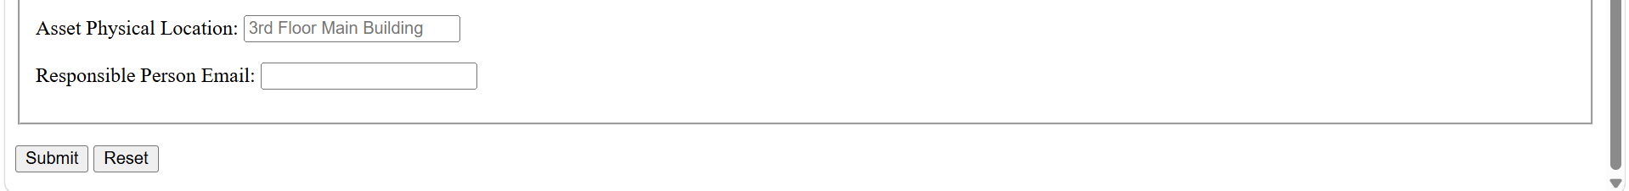

Caption: [Briefly describe what is shown]

3. Browser Result (continued)
[Insert screenshot here or write N/A]

Caption: [Briefly describe the tested links or elements]

4. Git Evidence
Insert one terminal screenshot showing the final Assignment 1.1 commit in git log.
Git Log Screenshot
no changes added to commit (use "git add" and/or "git commit -a")
C:\Users\garin\OneDrive\Documents\Kuliah\Semester 3\Pemprograman akuntansi dasar>git add .
C:\Users\garin\OneDrive\Documents\Kuliah\Semester 3\Pemprograman akuntansi dasar>git status
On branch master
Your branch is up to date with 'origin/master'.
Changes to be committed:
(use "git restore --staged <file>..." to unstage)
modified: Week 3/Chapter 3/index.html
new file: Week 3/Company Fixed Asset Recording Form/index.html

C:\Users\garin\OneDrive\Documents\Kuliah\Semester 3\Pemprograman akuntansi dasar>git commit -m "Add company fixed asset recording form"
[master 4f7cdb5] Add company fixed asset recording form
2 files changed, 132 insertions(+), 1 deletion(-)
create mode 100644 Week 3/Company Fixed Asset Recording Form/index.html
C:\Users\garin\OneDrive\Documents\Kuliah\Semester 3\Pemprograman akuntansi dasar>git push
Enumerating objects: 11, done.
Counting objects: 100% (11/11), done.
Delta compression using up to 12 threads
Compressing objects: 100% (5/5), done.
Writing objects: 100% (7/7), 1.75 KiB | 1.75 MiB/s, done.
Total 7 (delta 2), reused 0 (delta 0), pack-reused 0 (from 0)
remote: Resolving deltas: 100% (2/2), completed with 2 local objects.
To https://github.com/garinisahasrakirana-blue/Kira_ring.git
c03b68f..4f7cdb5 master -> master
C:\Users\garin\OneDrive\Documents\Kuliah\Semester 3\Pemprograman akuntansi dasar>

5. Conclusion
Short Conclusion
In conclusion, this assignment helped students understand how to create a fixed asset recording form using HTML. Students learned how to use form elements such as text fields, number fields, date inputs, radio buttons, dropdown menus, file uploads, and buttons. The assignment also helped students practice organizing accounting data into clear and structured sections.
Through this assignment, students gained practical experience in applying HTML to accounting data input and learned how to manage their project using Git and GitHub.

6. Final Checklist
☐ Student identity is complete.
☐ Final Assignment 3 HTML code is included.
☐ Browser screenshot(s) clearly show the completed page.
☐ The final Assignment 3 commit appears in the Git screenshot.
☐ The report has been checked and exported to PDF.
Student Name | Student Signature | Lecturer Signature
[Type here] | [Sign here] | [Sign here]

